**Count check with base table :**

select count(*),n_key

from pgcmdb_mdwdb.f_n_configuration_item_monthly_tgf_c

where soft_deleted_flag='N'

group by n_key;

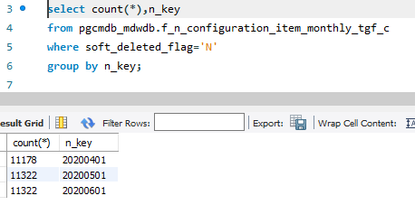

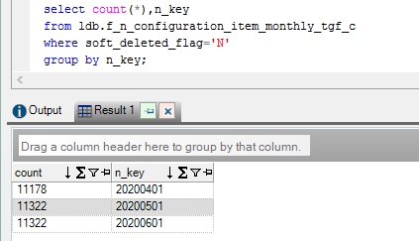

**Base table query used:**

select count(*) from

(SELECT MAX(d.row_id) as row_id,

MAX(d.row_key) as row_key,

MAX(d.source_id) as source_id,

MAX(d.cdctype) as cdctype,

MAX(d.changed_by) as changed_by,

MAX(d.changed_on) as changed_on,

MAX(d.created_by) as created_by,

MAX(d.created_on) as created_on,

MAX(d.dw_updated_on) as dw_updated_on,

MAX(d.dw_inserted_on) as dw_inserted_on,

MAX(d.secondary1_changed_on) as secondary1_changed_on,

MAX(d.secondary2_changed_on) as secondary2_changed_on,

MAX(d.soft_deleted_flag) as soft_deleted_flag,

0 as calendar_code,

MAX(d.created_on) as pivot_date,

d.scorecard_name_c, f.assignment_group_key, d.location_key, d.cmdb_ci_discovery_source_c_key, d.class,

SUM(f.completeness_total_count_c) as completeness_total_count_c, SUM(completeness_scope_count_c) as completeness_scope_count_c, SUM(correctness_total_count_c) as correctness_total_count_c, SUM(correctness_scope_count_c) as correctness_scope_count_c

FROM pgcmdb_mdwdb.f_configuration_item f

JOIN pgcmdb_mdwdb.d_configuration_item d ON f.configuration_item_key=d.row_key

WHERE f.soft_deleted_flag='N' AND d.source_type_c='Service Now'

GROUP BY d.scorecard_name_c, f.assignment_group_key, d.location_key, d.cmdb_ci_discovery_source_c_key, d.class

) a;

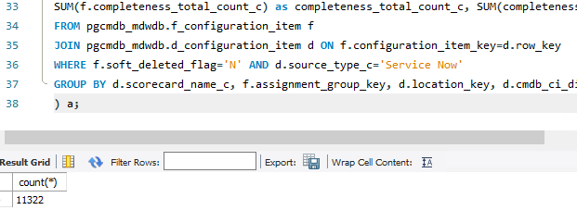

**Sampling between snapshot fact and base tables:**

**Snapshot fact:**

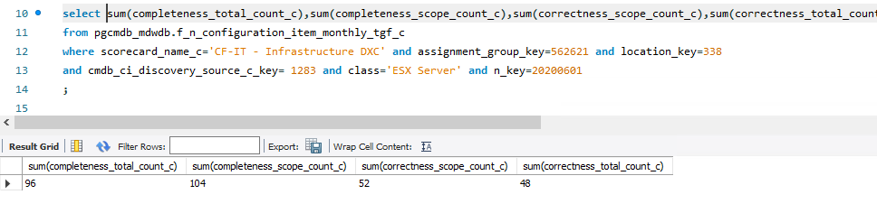

**Base tables:**

